# Getting started with Cognigy.AI

## Overview

Cognigy.AI is an AI conversational platform with which you can build, deploy, and manage conversational experiences for your customers across various channels such as websites, mobile apps, messaging platforms, and voice assistants.

With the no-code approach, your team can create and manage AI-powered conversations without coding and IT dependencies. The Natural Language Understanding(NLU) and the Generative AI integration facilitate human-like conversations to enhance personal connections with your customers.

[Learn more about the capabilities of Cognigy.AI](https://www.cognigy.com/platform/cognigy-ai)

Cognigy.AI is for projects of any size and type, from small-scale chatbots to large-scale virtual assistant deployment. The flexible architecture will help you to adapt and evolve your conversational solutions over time and integrate them with your existing workflows.

If you are a beginner or are new to Cognigy.AI, use this guide as a reference document to understand the platform and navigate the basic functionalities.

## Installation and configuration

The Cognigy.AI User Interface is compatible with the below-listed browsers:

| **Browser** | **Version** |
| --- | --- |
| Google Chrome | 112, 113 |
| Firefox | 112,113 |
| Microsft Edge | 112,113 |
| Safari | 15.6,16.3 |

### Software requirements

To install the Cognigy.AI platform, a fully functional **Kubernetes cluster** is mandatory. We recommend using a managed Kubernetes cluster provided by common public cloud operators (Amazon EKS, Microsoft AKS, Google GKE).

Cognigy.AI is fully compatible with the following managed Kubernetes services:

* **AWS EKS**
* **Azure AKS**

*Kubernets versions compatible with Cognigy.AI are specified in the* [*Cognigy.AI Helm Chart*](https://github.com/Cognigy/cognigy-ai-helm-chart)*.*

### Hardware requirements

For the installation of Cognigy.AI with ***English*** as the default Natural Language Understanding (NLU) language, use a Kubernetes cluster that meets the following specifications for AWS EKS (or similar setups on alternative cloud platforms):

* At least 6 x c5.2xlarge (AWS) or 6 x Standard_F8s_v2 (Azure) worker nodes or equivalent VMs with 8 CPU/16 GB RAM and x86_64 CPU architecture on other cloud providers.
* 100 GB root SSD storage per worker node.
* Kubernetes worker nodes are distributed across 3 Availability Zones (AZ) for high availability setup.
* 250 GB of block SSD storage for application databases (250 GB x 3 for 3-replica MongoDB setup).
* 10 GB of file system storage (EFS or other NFS-compatible equivalents) for application assets.

[Learn more about the prerequisites](https://docs.cognigy.com/ai/installation/overview/)

### Installing Cognigy.AI

To install Cognigy.AI,

1. Install MongoDB database with [MongoDB Helm Chart for Cognigy.AI](https://github.com/Cognigy/cognigy-mongodb-helm-chart). For the latest installation guide, refer [README.md](https://github.com/Cognigy/cognigy-mongodb-helm-chart#readme).
2. Install Cognigy.AI with [Cognigy.AI Helm Chart](https://github.com/Cognigy/cognigy-ai-helm-chart). For the latest installation guide, refer [README.md](https://github.com/Cognigy/cognigy-ai-helm-chart#readme).

Once both Helm releases are successfully installed, open a web browser and visit the URL which you have set in *serviceUi.host* parameter Cognigy.AI Helm release. You will now see the Cognigy.AI login screen:

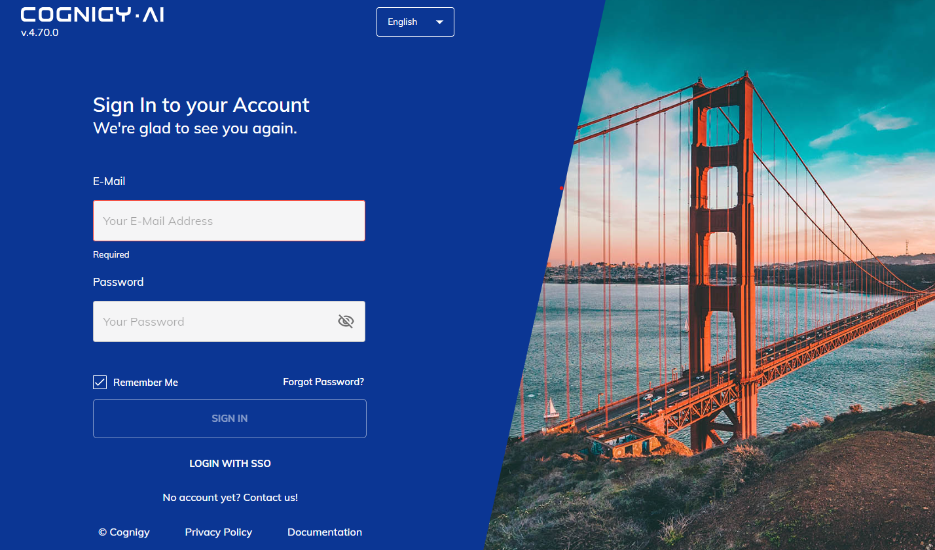

*Cognigy.Ai V4*

[Learn more about Congingy.AI login and configuration](https://docs.cognigy.com/ai/installation/installation-process/)

## Navigating Cognigy.AI

To help you navigate the Cognigy.AI interface and understand its capabilities and functionalities, several inbuilt [**Journeys**](https://support.cognigy.com/hc/en-us/articles/360015519100-Use-Journeys-to-learn-more-about-Cognigy-AI) are integrated into the platform.

**Note:** You will find the Journey widget on your agent dashboard.

### Create your first Virtual Agent

Virtual Agents are bots that will help you interact with users in natural language, understand their inquiries, and provide accurate and helpful responses.

*The tutorial loop can be placed here to give better visibility and access.*

1. Navigate to the **Create Agent** wizard on the top left of your Cognigy.AI dashboard. Launch the wizard by clicking on it.
2. Give your VA a descriptive **name** like "My New Agent."
3. Choose the **primary language**. Picking a **color** will help you quickly navigate between VAs once you've set up the whole workforce.
4. Select the **Blank template** as a foundation for your VA.
5. Confirm **Webchat** as the output channel for your bot.
6. Skip adding **Skills** and don't include Smalltalk capability for this tutorial.
7. Click "**Go to Agent**" to begin adding more capabilities to your first VA.

**Note:** You can create unlimited VAs, each designed for a single use case but capable of handling multiple user intents.

The next step is to create your first conversation Flow and have it send a message.

### Building a conversation flow

A conversation flow is like a map that shows how your Virtual Agent (VA) talks with users. It lays out what your VA can do and how it handles the chat.

[Learn more about Flows](https://docs.cognigy.com/ai/resources/build/flows/?_gl=1*1gkwn90*_ga*MTQzNTg5NjU2OS4xNzA5MTUwNDU1*_ga_VVVD0H4SMG*MTcwOTIwNzA1Ny4yLjEuMTcwOTIwNzA1OC4wLjAuMA..).

To create a new flow,

1. Open the "**Build**" menu from the left sidebar.
2. Select "**Flows.**"
3. Click "**New Flow**."
4. Give your Flow a name, like "Flow 1" for now.
5. Save it and you'll see the Flow editor with a Start and End Node.

To add a Say Node,

1. Click the **plus icon** located between the Start and End nodes in the flow editor.
2. This action opens a menu where you can add nodes defining the VA's actions.
3. Select the "**Say Node**” option to allow the VA to respond with a message.

Learn more about Say Node

To configure the conversation,

1. Click on the **Say Node** to edit it. Find the Text field and input your desired message.
2. Save the Node.

**Note:** If you add another line, the VA will randomly use one of the texts.

You can now chat with your Virtual Agent!

### Chat with your Virtual Agent

You can talk to your Virtual Agent (VA) anytime using the Interaction Panel. It's the primary tool for your team to test and improve your VA.

[Learn more about the Interaction Panel](https://docs.cognigy.com/ai/tools/interaction-panel/interaction-panel/?_gl=1*rqg4nl*_ga*MTQzNTg5NjU2OS4xNzA5MTUwNDU1*_ga_VVVD0H4SMG*MTcwOTIwNzA1Ny4yLjEuMTcwOTIxMDEyNC4wLjAuMA..).

To chat with your VA,

1. Navigate to the speech bubble icon at the top-right to open the **Interaction Panel.**
2. Say hello to your VA by typing "hello!" into the input field and click the **send icon** or press **Enter**. Your message is now sent to your Virtual Agent and you'll see its response immediately.
3. To clear the chat, you can either use the "**more options**" menu (three dots) or press **Ctrl + B**.

It is time for the VA to ask the questions and collect data.

### Let the Virtual Agent ask questions

Your Virtual Agent (VA) can talk to human users and gather all the data it needs for a successful conversation. Let's begin by having the VA ask a simple question.

To configure the questions,

1. Select the **plus** sign after the Say Node in the flow editor to add a [Question Node](https://docs.cognigy.com/ai/nodes/basic/question/?_gl=1*1x16vhv*_ga*MTQzNTg5NjU2OS4xNzA5MTUwNDU1*_ga_VVVD0H4SMG*MTcwOTIwNzA1Ny4yLjEuMTcwOTIxMDg2Mi4wLjAuMA..).
2. Click on the **Question Node** to edit it.
3. In the **Edit Node** Window, choose your **Question Type** from the question templates. Types are designed to transform user entries into well-defined datasets that can be easily processed later in the Flow.
4. Here, you can select the question type as "Text" to allow free form entry.
5. Add a question in the **Text** field, e.g.: What is your name?

To make the VA answer using the data collected,

1. Add a **Say Node** after the Question Node.
2. In the **Text** field of the Say Node, enter a greeting like "Hello" followed by a space.
3. Click on the **AI icon** located on the right side of the text field.
4. From the options, select "**Last Question Result**" and **Save** the Node.

This setup will prompt the user's input to be used in the response of the Virtual Agent, making the conversation more interactive and personalized.

The basic conversation flow is configured and you can now make your Virtual Agent public.

### Deploy your Virtual Agent

So far, your Virtual Agent (VA) has only been within Cognigy.AI. To let it interact outside of the Interaction Panel, we need to deploy it. Adding one or more Endpoints allows your end-users to access it through channels of your choice.

[Learn more about Endpoints](https://docs.cognigy.com/ai/endpoints/overview/?_gl=1*qik4s6*_ga*MTQzNTg5NjU2OS4xNzA5MTUwNDU1*_ga_VVVD0H4SMG*MTcwOTIwNzA1Ny4yLjEuMTcwOTIxMjgyMy4wLjAuMA..)

To deploy your Virtual Agent,

1. Go to "**Deploy**" in the left sidebar and select "**Endpoints**."
2. Click "**New Endpoint**."
3. Give it a name, like "**Web**," and select "**Webchat**" as the Endpoint Type.
4. Choose your **Main Flow**, which the Endpoint starts executing (e.g., "Flow 1").
5. **Save** it.
6. Open your Endpoint in a browser by clicking "**Open Webchat.**"

Your Virtual Agent is now accessible outside of Cognigy.AI! You can share the link with others to showcase your achievements.

[Learn how to train your VA to be smart and intuitive.](https://support.cognigy.com/hc/en-us/articles/360014776879-Train-your-Virtual-Agent-to-recognize-Intents)

Was this Helpful?